Report Title (Segoe UI, 28 pt., Bold)
  - Subtitle (Calibri, 20 pt., Bold)
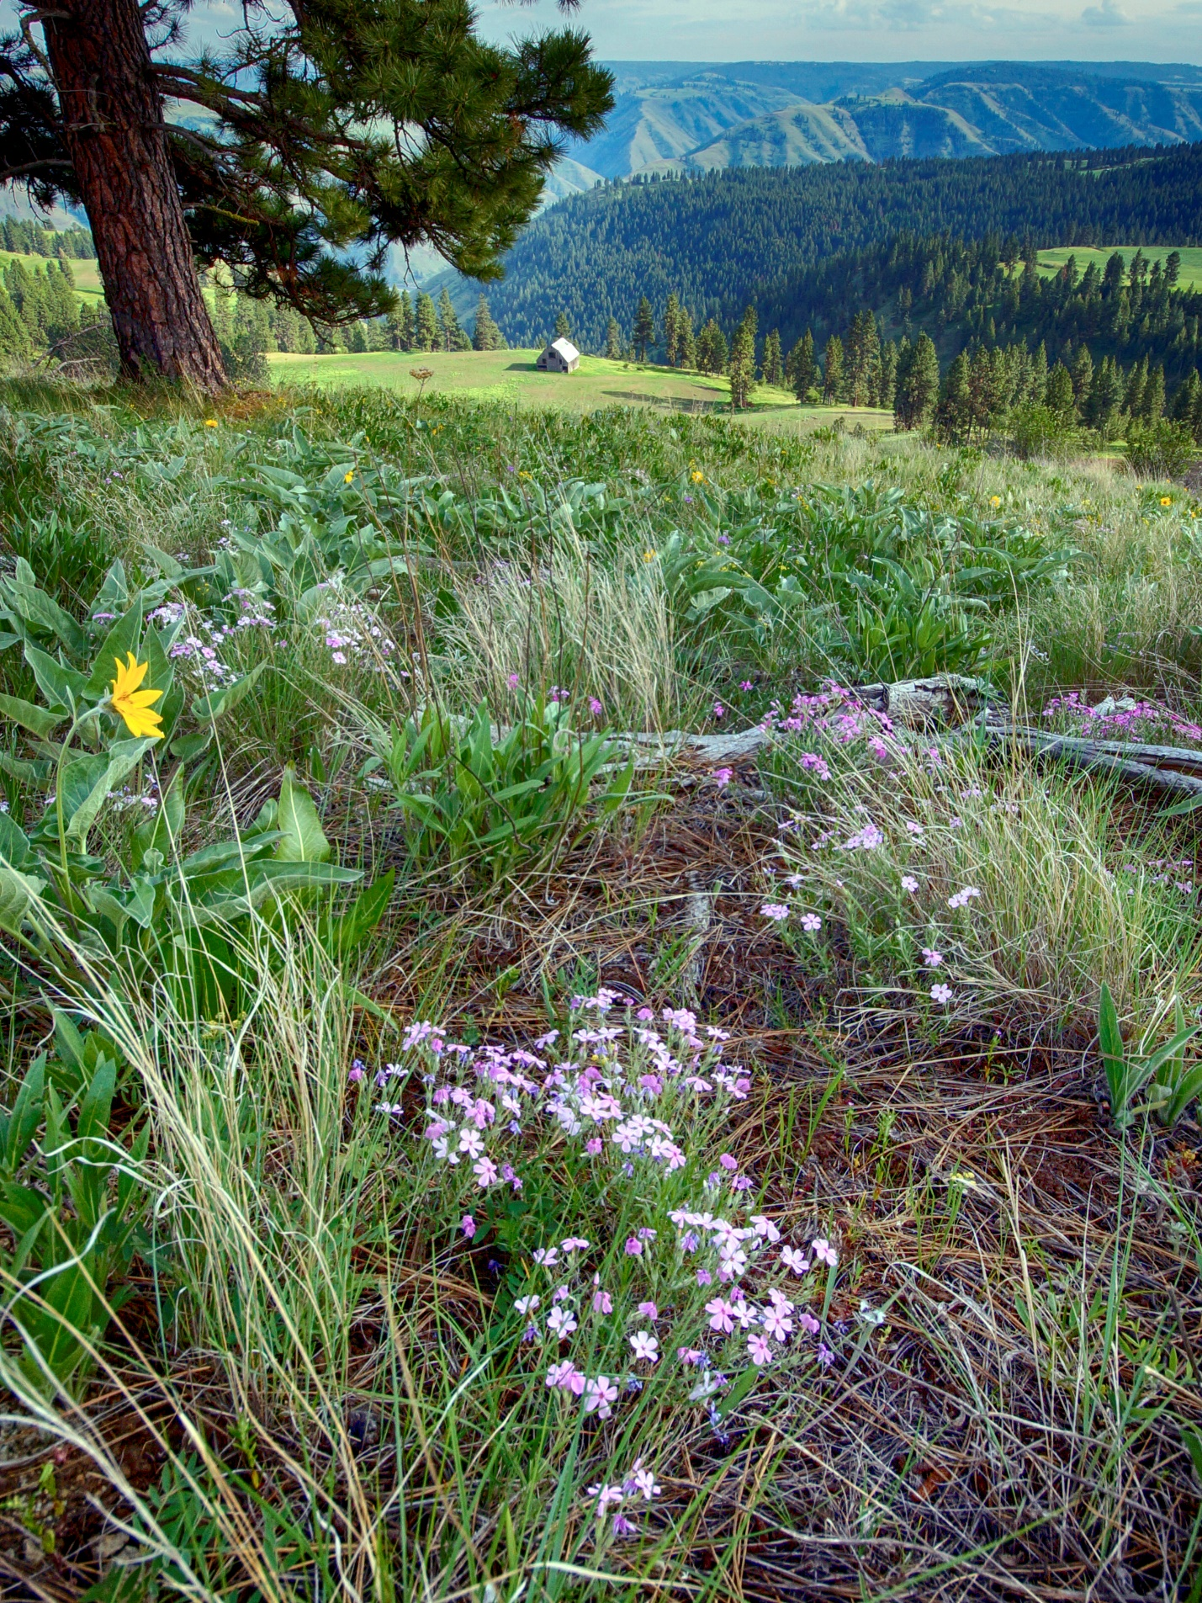

Report title
Subtitle
Author
INSERT AUTHOR NAME(S)

Report acknowledgements
OPTIONAL – Include a statement acknowledging report contributors.

Suggested citation
INSERT REPORT CITATION

Cover photo by [NAME or WDFW].
Request this information in an alternative format or language at wdfw.wa.gov/accessibility/requests-accommodation, 833-885-1012, TTY (711), or CivilRightsTeam@dfw.wa.gov.
Table of Contents
Acknowledging the Indigenous People of the Pacific Northwest 2
When to include this statement 2
Main report chapters (Segoe UI, 20 pt., Bold) 4
Heading 2 (Calibri, 16 pt., Bold) 4
Heading 3 (Calibri, 14 pt., Bold) 4
Photo guidance 5
Where to find photos 5
Photo formatting tips 5
Table guidance 6
Table formatting tips 6
Figure guidance 7
Figure formatting tips 7
Literature cited 8

List of Tables
Table 1. Descriptive name 6
Table 2. Another descriptive name 6

List of Figures
Figure 1. Descriptive name 7

Main report chapters (Segoe UI, 20 pt., Bold)

Heading 2 (Calibri, 16 pt., Bold)

Heading 3 (Calibri, 14 pt., Bold)

Heading 4 (Calibri, 12 pt., Bold)
Body Text (Calibri, 11 pt., 1.15 line spacing)
Hyperlinks (Hyperlink, blue, underlined text)
Footnotes (Calibri, 10 pt)
Short quotes and call out text (Quote, Segoe UI Semilight, 16, 1.15 line spacing) – use to highlight a main point
Note: Use the Styles gallery in this template to apply these pre-established font treatments throughout your report.

Photo guidance

Where to find photos
- WDFW Media Library
- Attempt to use WDFW and/or Washington state images when possible. Seek assistance from your communications manager if you need help locating an image.

Photo formatting tips
- Add alt text describing the scene. Right click photo > view alt text > edit.
- Add captions to all photos for context. Cover photos do not need captions. Photo credits are required for all photos. Use Photo caption style.
- Format photos In Line with Text. Click photo > picture format menu > wrap text > In Line with Text. Left align photos.
- Adjust spacing below photos. Click photo > select Photo spacing style.
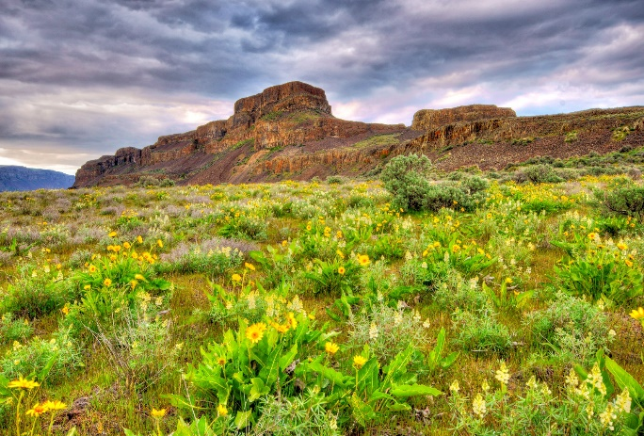
Photo caption. Photo by NAME.
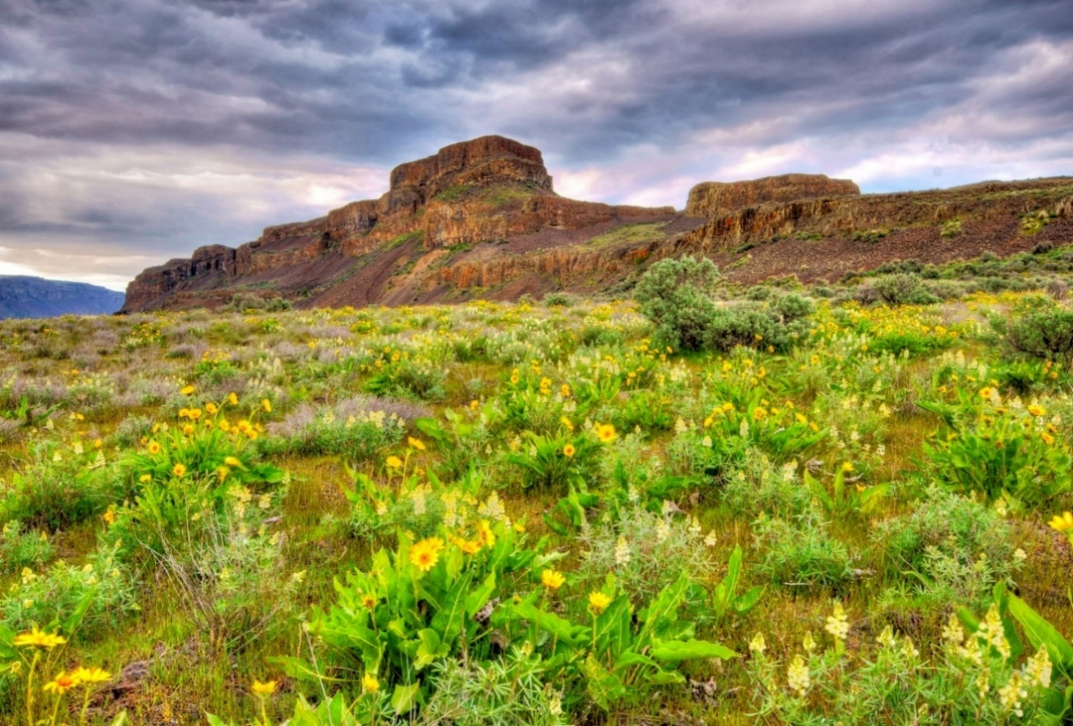
Photo caption. Photo by NAME.

Table guidance
The most accessible tables will have:
- Column headers, row headers, or both.
- Table alt text. Right click a table > Table Properties > Alt Text tab > Add title and description.
- No empty cells. Clear and minimal text in each cell.
- No merged cells.

Table formatting tips
This report template contains a built-in table style that is formatted for you. Simply insert a table and add your data. Consider using multiple tables to break down complex information.
Table 1. Descriptive name
Column 1 | Column 2 | Column 3 | Column 4 | Column 5
Table 2. Another descriptive name
Column 1 | Column 2 | Column 3

Figure guidance
The most accessible charts and graphs will have:
- A simple concept and defined purpose.
- Data differentiated by symbols or dashed lines in addition to color.
- Good color contrast.
- Figure alt text.

Figure formatting tips
- Add alt text that describes the figure. Right click figure > view alt text > edit.
- Include figure numbers and a short, descriptive name. Use Table and Figure titles style.
- Add brief captions for additional context. Use Photo caption style.
- Format figures In Line with Text. Click figure > picture format menu > wrap text > In Line with Text. Left justify figures.
- Adjust spacing below figures. Click figure > select Photo spacing style.
- Avoid formatting photos as numbered figures. Refer to photo guidance.
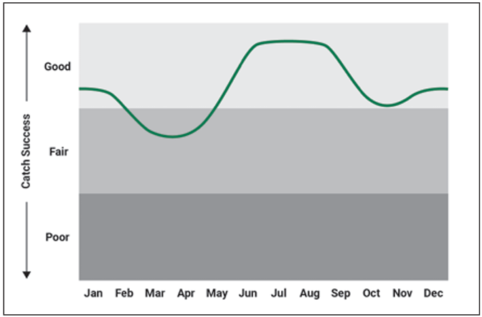
Figure 1. Descriptive name
Figure caption.

Literature cited
Add your citations here. Format them using the Literature citation style. They will look consistent and fabulous.
Add your citations here. Format them using the Literature citation style. They will look consistent and fabulous.

This is a footnote. Footnotes should be 10-point font so people can read them.
Another footnote.
So many footnotes!

